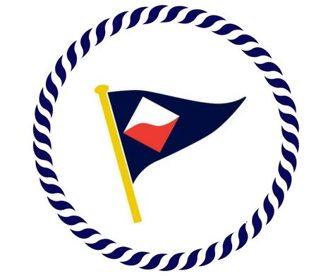

2020 GYC Junior Sailing
Pricing

 | 2020 GYC Member Rates | 2020 Non-GYC Member Rates
One 2-week session  (am OR pm) | $340 | $470
Two 2-week sessions  (am OR pm) | $560 | $940
Three 2-week sessions  (am OR pm) | $835 | $1410
Four 2-week sessions  (am OR pm) | $1025 | $1880

AM session is 9:00 am – 12:00 pm
PM session is 1:00 pm – 4:00 pm
Sessions do not need to be consecutive to qualify for discount pricing.
Boat specifications dictate that camp is limited to kids ages 8-14 and under 135 pounds.

Session 1: June 22 – July 3
Session 2: July 6 – July 17
Session 3: July 20 – July 31
Session 4: August 3 – August 14

